Mama B Bakes – Part 2 README
Project Overview
Mama B Bakes is a responsive bakery website created to showcase baked products, provide company information, and allow customers to submit enquiries online.
This part of the project focused on:
- CSS styling
- responsive design
- typography
- layout design
- mobile responsiveness

CSS Styling Implementation
External Stylesheet
An external stylesheet named style.css was created and linked to all HTML pages.
The stylesheet uses:
- consistent naming conventions
- reusable CSS variables
- grouped selectors
- cascading styles

Base Styling
The website uses:
- a pastel pink, cream, and brown colour palette
- global typography settings
- spacing and layout consistency
A CSS reset was implemented using:
*, *::before, *::after {
box-sizing: border-box;
margin: 0;
padding: 0;
}

Typography
Typography choices:
- Headings: Elegant script style using Playfair Display
- Body text: Sans-serif font using Nunito
Typography styling includes:
- font-family
- font-size
- font-weight
- line-height
- letter-spacing

Layout Structure
CSS Flexbox and CSS Grid were used throughout the website.
Examples:
- Flexbox for navigation and forms
- CSS Grid for the products section
The layout was designed to:
- be easy to navigate
- remain visually balanced
- support responsive resizing

Visual Styling
Visual styling techniques used:
- gradients
- box shadows
- rounded corners
- hover effects
- focus effects
- colour variables

Responsive Design
Breakpoints
Media queries were used to adapt the website for smaller screens.
Breakpoint used:
- 700px and below for mobile devices
Responsive changes include:
- hamburger navigation menu
- single-column product layout
- responsive forms
- resized typography
- adjusted spacing

Relative Units
Relative units used:
- rem
- %
- fr
These units improve responsiveness across different screen sizes.

Responsive Images
Responsive image techniques used:
- srcset
- sizes
- max-width: 100%
- height: auto
These techniques help images scale correctly on different devices.

Testing and Developer Tools
Google Chrome Developer Tools were used to:
- test responsiveness
- inspect CSS
- preview different devices
- test mobile layouts
Devices tested:
- Desktop
- Tablet
- Mobile

Screenshots
The screenshots are in mobile and desktop perspectives
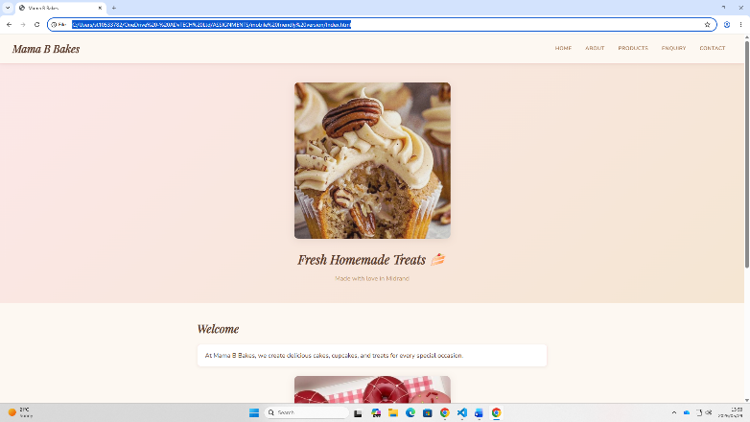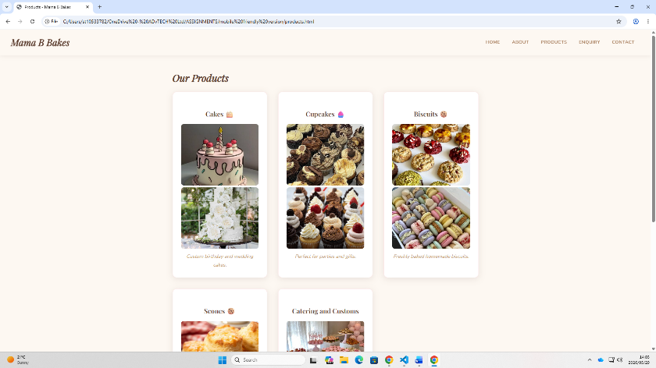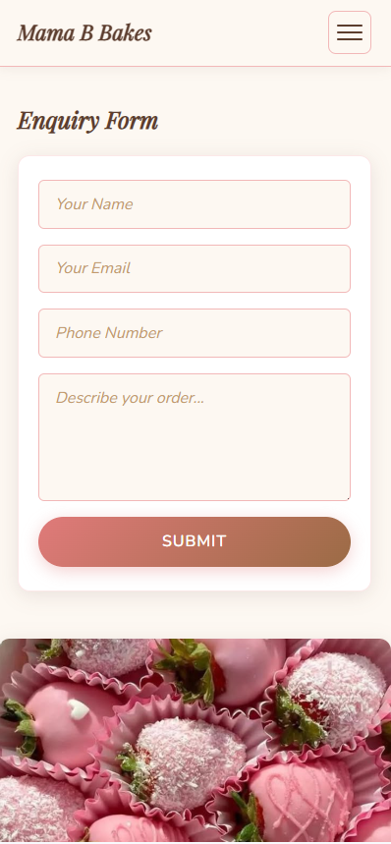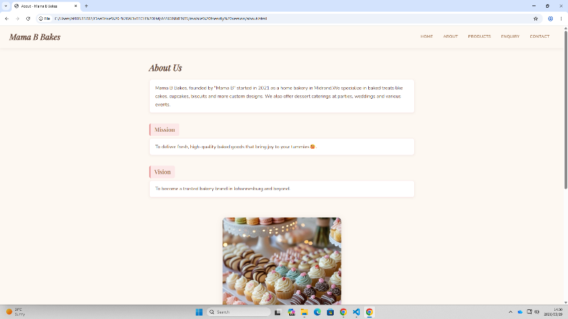

Changelog
Changes Made from Part 1
- Added external CSS stylesheet
- Implemented responsive design
- Added mobile hamburger navigation
- Styled forms and product layouts
- Added responsive images
- Improved typography and colour consistency
- Added hover and focus effects
- Improved spacing and layout structure

References
References
CSS Tricks, 2025. A Complete Guide to Flexbox. [online] Available at: https://css-tricks.com/snippets/css/a-guide-to-flexbox/
[Accessed 29 May 2026].
CSS Tricks, 2025. A Complete Guide to Grid. [online] Available at: https://css-tricks.com/snippets/css/complete-guide-grid/
[Accessed 29 May 2026].
Google Fonts, 2026. Google Fonts. [online] Available at: https://fonts.google.com/
[Accessed 29 May 2026].
HostAfrica, 2025. Web Hosting Pricing. [online] Available at: https://www.hostafrica.co.za/
[Accessed 31 Mar. 2026].
Krug, S., 2014. Don’t Make Me Think: A Common Sense Approach to Web Usability. 3rd ed. Berkeley: New Riders.
MDN Web Docs, 2026. CSS: Cascading Style Sheets. [online] Available at: https://developer.mozilla.org/en-US/docs/Web/CSS
[Accessed 29 May 2026].
MDN Web Docs, 2026. Responsive Design. [online] Available at: https://developer.mozilla.org/en-US/docs/Learn_web_development/Core/CSS_layout/Responsive_Design
[Accessed 29 May 2026].
Nielsen, J., 2012. Usability 101: Introduction to Usability. [online] Nielsen Norman Group. Available at: https://www.nngroup.com/articles/usability-101-introduction-to-usability/
[Accessed 31 Mar. 2026].
W3Schools, 2026. CSS Tutorial. [online] Available at: https://www.w3schools.com/css/
[Accessed 29 May 2026].
W3Schools, 2026. CSS Responsive Web Design. [online] Available at: https://www.w3schools.com/css/css_rwd_intro.asp
[Accessed 29 May 2026].

GitHub Repository
GitHub Repository Link:
(Paste repository link here)

Author
Student Name: Bophelo Rameetse
Student number: ST10533782
Year: 2026

